Project Name: Docker Swarm - Voting application
Objective | To deploy a scalable, multi-service voting application on a manager node,  ensuring efficient orchestration, fault tolerance, and seamless monitoring  through Docker visualizer
Problem Statement and Motivation | John, a DevOps engineer, is tasked with deploying a voting application  through multiple microservices. By creating a Docker compose file and  deploying it on a manager node in a distributed system, they ensure that  each service is efficiently orchestrated and fault-tolerant.  To monitor the deployment, John integrates Docker visualizer as a  microservice, providing real-time insights. This setup simplifies the  deployment process, enhances scalability, and ensures the application runs  smoothly in a production environment.
Create EC2 instances | node public-ip private-ip  master 100.54.98.51 172.31.70.132  ndoe1 3.238.241.115 172.31.72.215  node2 3.237.27.49 172.31.75.77  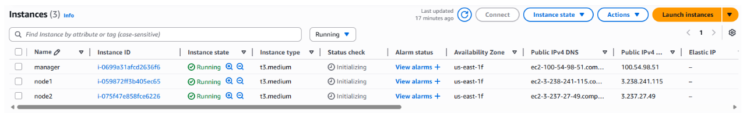
Install docker on all 3 instances | sudo su  apt update -y  apt install docker.io -y
Install docker swarm on master node | # master: 100.54.98.51  docker swarm init --advertise-addr 172.31.70.132  #note down node join command
join node1 and node2 in swarm cluster | #node join command  docker swarm join --token SWMTKN-1-1s3jiuk6saa2ps6h5602zdz2gko6sfgusm2nx7n2d4jq9aftt6-0zjceti04fntt7j3dwft5pmzx 172.31.70.132:2377
overview of voting website | - Home page with 4 political party buttons  - Vote page that saves the vote in a free MySQL database  - Results page to see totals  - Uses PHP + MySQL (works on free hosting like InfinityFree, 000webhost, or Hostinger free plans)
Structure: | voting-app/  ├── Dockerfile  ├── index.php  ├── vote.php  ├── results.php  └── db.php
Dockerfile | FROM php:8.2-apache  RUN apt update -y  RUN apt install git -y  RUN git clone https://github.com/pradeepviswa/voting-app.git /var/www/html  RUN ls /var/www/html  RUN docker-php-ext-install mysqli  #check mysqli  RUN php -i | grep mysqli
Build Docker Image | docker build -t voting-image .
Create Overlay Network | docker network create \  --driver overlay \  voting-network
Check new network | docker network ls  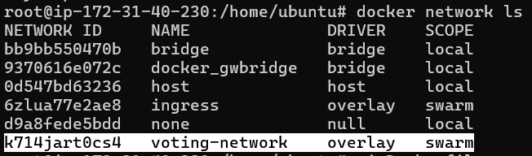
Create MySQL Service | docker service create \  --name voting-mysql \  --network voting-network \  -e MYSQL_ROOT_PASSWORD=root \  -e MYSQL_DATABASE=voting_db \  mysql:8  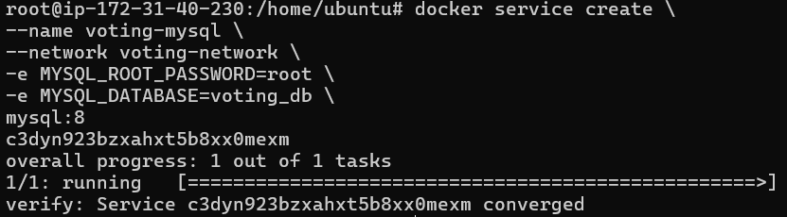
Create Web Service | docker service create \  --name voting-web \  --network voting-network \  -p 8080:80 \  voting-image  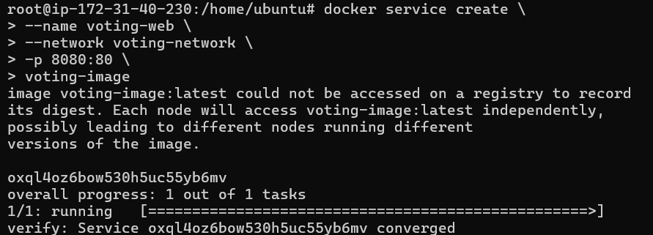
Check service: | docker service ls
Database Connection | My db.php uses the service name as hostname:  $host = "voting-mysql";  Swarm DNS automatically resolves the service.
Enter MySQL Service to Create Table | get container ID: docker ps  Connect mysql: docker exec -it <mysql_container_id> mysql -u root -p  #password is root  Create table:  USE voting_db;  CREATE TABLE votes (  id INT AUTO_INCREMENT PRIMARY KEY,  party VARCHAR(50)  );
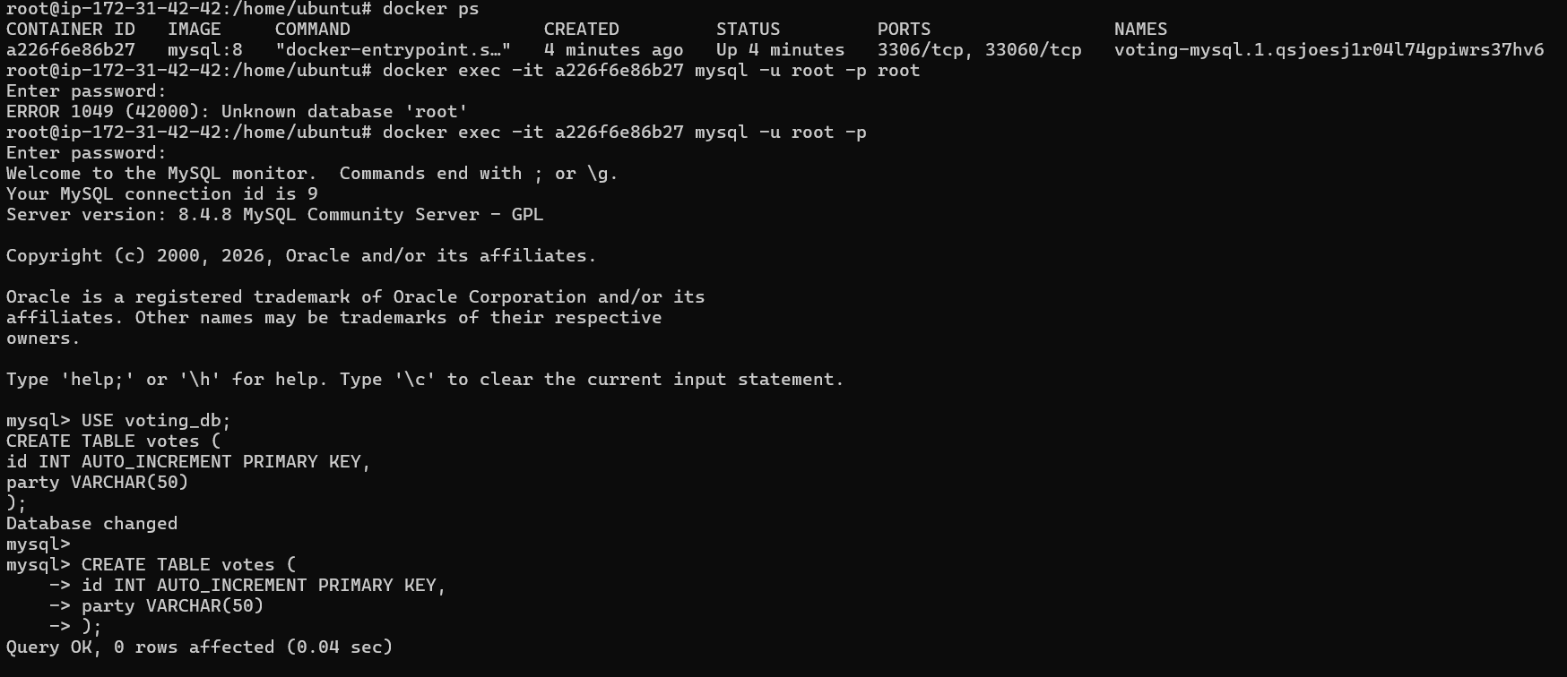
Scale the Web Service (Swarm advantage) | docker service scale voting-web=3  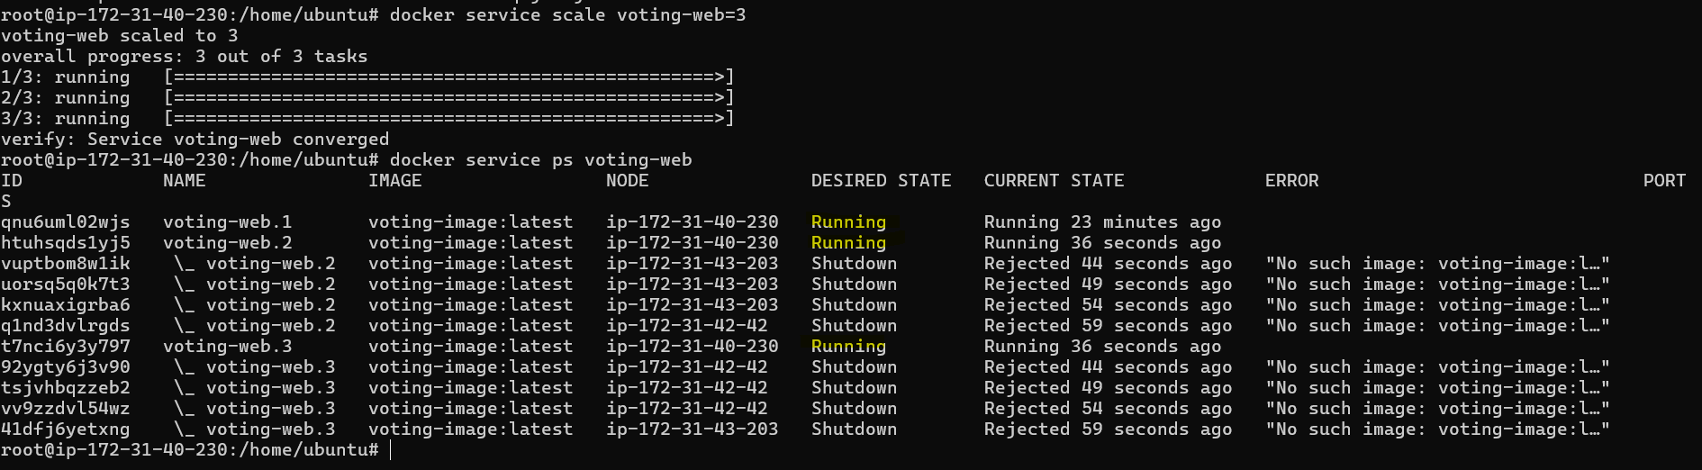

Output:

Open Website  And  Click on different buttons multiple times | 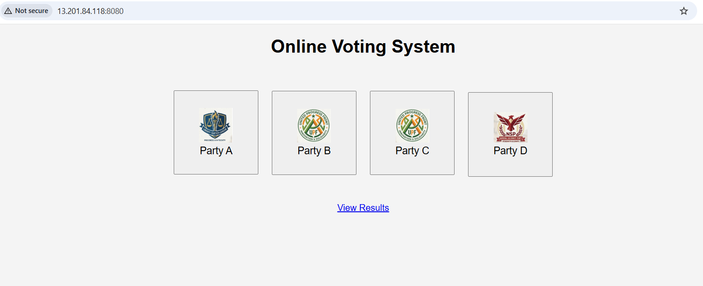
When clicked on any button here is the output | 
See Results page | 

